PROJECT STRUCTURE
Table 1
DATE | 19 NOVEMBER 2022
Team ID | PNT2022TMID34104
PROJECT | Classifications of arrhythmia by using deep learning 2-D ECG spectral image representation

We are building a Flask Application that needs HTML pages stored in the templates folder and a python script app.py for serverside scripting
- we need the model which is saved and the saved model in this content is ECG.h5
- The static folder will contain js and CSS files.

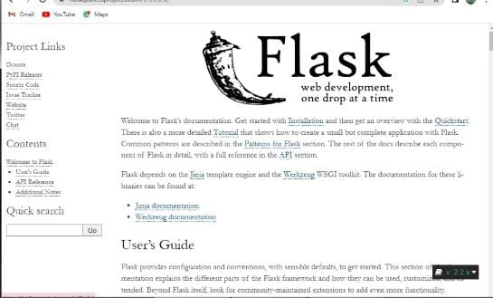
Figure 1

